What does God do for you?
1) He offers you love, connection, provision, and protection
- You are loved – Jeremiah 31:3
- You belong – Ephesians 1:6-7, 13-14, Song of Solomon 8:6
- You have provision – John 10:10, 2 Corinthians 9:8
- You are protected – Psalm 32:7

2) He gives you eternal life and saves you form hell – Matthew 25:46, John 3:16
- Heaven – Revelation 22:12-17
- Hell – Revelation 20:11-15

3) The prodigal son – Luke 15:11-24
- What do we give to God and what does he give to us?
- We give him our broken lives and makes us kings and priests

And have made us kings and priests to our God; And we shall reign on the earth.
Revelation 5:10

Now therefore, if you will indeed obey My voice and keep My covenant, then you shall be a special treasure to Me above all people; for all the earth is Mine. And you shall be to Me a kingdom of priests and a holy nation. These are the words which you shall speak to the children of Israel.
Exodus 19:5-6

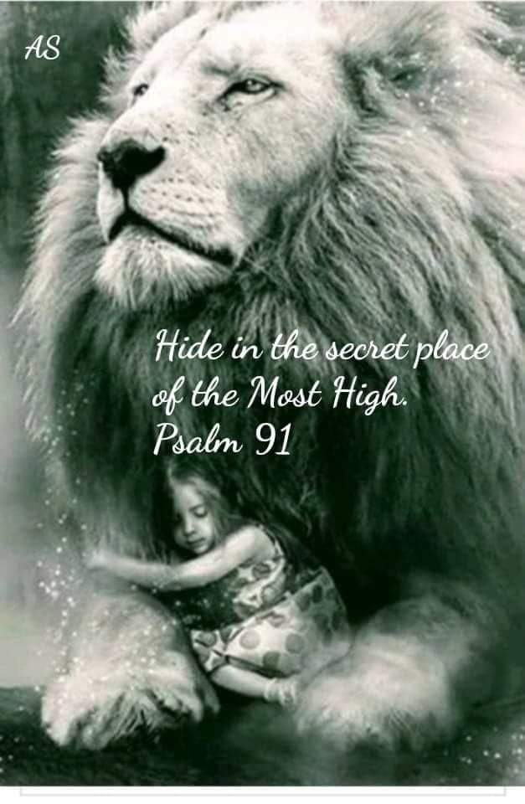
For whoever calls on the name of the Lord shall be saved.
Romans 10:13, Romans 10:9-13

Lecrae’ (Moore), is a rapper, entrepreneur, record-producer, and actor. He speaks for many of us when he says, “I’m not a Christian because I’m strong and have it all together. I’m a Christian because I’m weak and admit I need a savior.”

