The Widow of Nain

Luke 7:11-17
God wants to stop the parade of death in your life and give you a fresh start and new hope. This is made possible because of the resurrection of Jesus from the dead (Joel 2:25)
- And God both raised up the Lord and will also raise us up by His power. I Corinthians 6:1
- Blessed be the God and Father of our Lord Jesus Christ, who according to His abundant mercy has begotten us again to a living hope through the resurrection of Jesus Christ from the dead. I Peter 1:3

1) Widows and orphans
- God holds a special place in His heart for widows and orphans; basically, all the vulnerable and unprotected – Isaiah 1:16-17
- Pure and undefiled religion before God and the Father is this: to visit orphans and widows in their trouble, and to keep oneself unspotted from the world. James 1:27
- God sends Elijah to a widow – 1 Kings 17:8-24

2. Compassion was the motive for this miracle
- At least five of Jesus’ miracles were motivated by His compassion – Matthew 14:13-21
- And when Jesus went out He saw a great multitude; and He was moved with compassion for them, and healed their sick. Matthew 14:14
- Through the Lord ’s mercies we are not consumed, Because His compassions fail not. They are new every morning; Great is Your faithfulness. Lamentations 3:22-23

3. Do not weep
- Do not weep because there is hope – Jeremiah 31:16-17
- Do not weep because God is doing a new thing – Isaiah 43:18-19
- Do not weep because all things will be made new – Revelation 7:17, 21:3-8

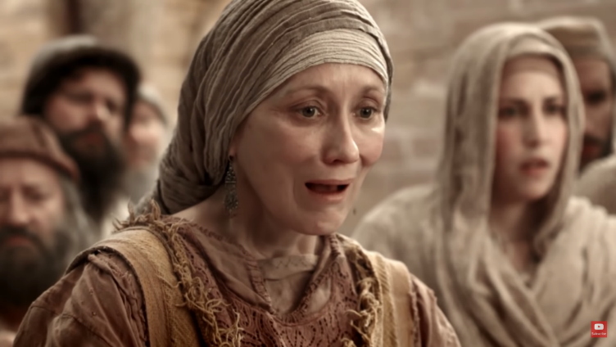
For I know the thoughts that I think toward you, says the Lord, thoughts of peace and not of evil, to give you a future and a hope. Then you will call upon Me and go and pray to Me, and I will listen to you. And you will seek Me and find Me, when you search for Me with all your heart. Jeremiah 29:11-13

