Is anything too hard for the Lord
Is anything too hard for the Lord? At the appointed time I will return to you, according to the time of life, and Sarah shall have a son. Genesis 18:14

Behold, I am the Lord, the God of all flesh. Is there anything too hard for Me? Jeremiah 32:27

Behold, I am the Lord, the God of all flesh. Is there anything too hard for Me? ‘Ah, Lord God! Behold, You have made the heavens and the earth by Your great power and outstretched arm. There is nothing too hard for You. Jeremiah 32:17

Matthew 9:18-37
1) A girl is restored to life and a woman healed – vs.18-26
Jesus has power over death and terminal illness
- “For she said…” Her confession was important – Matthew 17:20
- “If only I may touch His garment, I shall be well.” – Matthew 14:34-36, Numbers 15:37-41
- “But when the crowd was put outside.” The ridiculing, unbelieving crowd created a negative atmosphere – Mark 6:5

2) Two blind men healed – vs.27-31
Jesus has power over blindness
- “According to your faith let it be to you.”
- Jesus said to him, “If you can believe, all things are possible to him who believes.”
Mark 9:23

3) A mute man speaks – vs.32-34
Jesus has power over demons
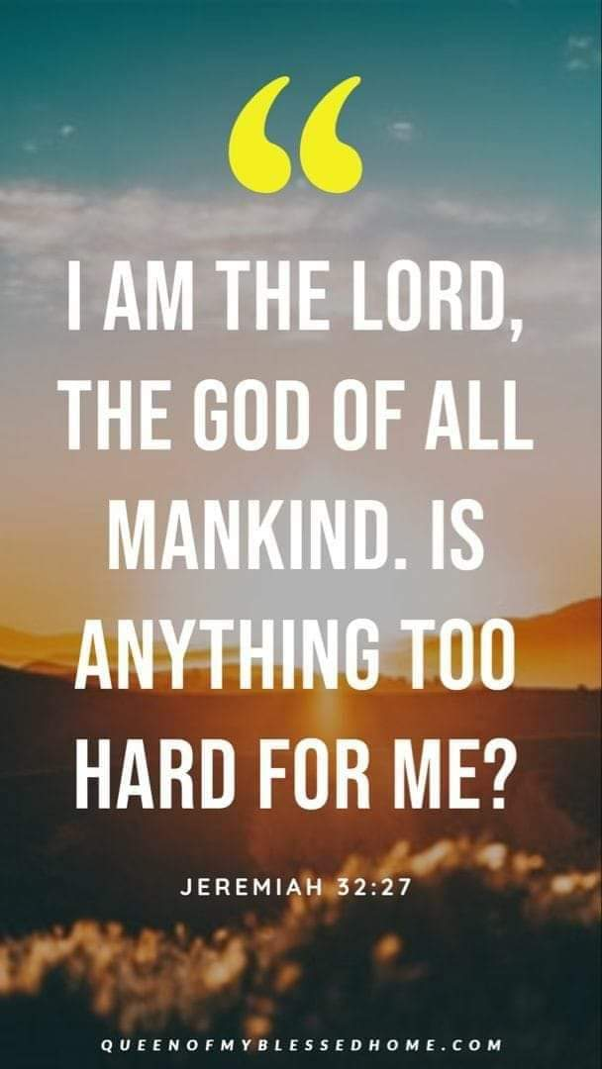
- Jesus has given you power over demons – Matthew 10:1, Luke 10:19-20

4) The compassion of Jesus – vs.35-38
Jesus has power over every sickness and every disease
- Through the Lord ’s mercies we are not consumed, Because His compassions fail not. They are new every morning; Great is Your faithfulness. Lamentations 3:22-23
- And when Jesus went out He saw a great multitude; and He was moved with compassion for them, and healed their sick. Matthew 14:14
- And he arose and came to his father. But when he was still a great way off, his father saw him and had compassion, and ran and fell on his neck and kissed him. Luke 15:20

