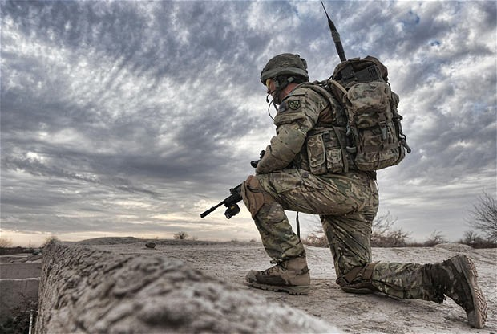Hold your position

Your faith will be challenged. Don’t waver in your resolve and you will be rewarded (Hebrews 11:6)

King Jehoshaphat faced an impossible situation but he and Judah held their position of faith and were delivered and rewarded.

*-Therefore take up the whole armor of God, that you may be able to withstand in the evil day, and having done all, to stand. Ephesians 6:13*

*-You will not need to fight in this battle. Position yourselves, stand still and see the salvation of the Lord, who is with you, O Judah and Jerusalem! Do not fear or be dismayed; tomorrow go out against them, for the Lord is with you. II Chronicles 20:17*

# 2 Chronicles 20

1) Hold your position when your faith is challenged – vs.1

* “It happened after this.” After the Kingdom began devoting themselves to God the enemy came to challenge their faith – Matthew 13:18-23

2) Hold your position by fasting and praying the promises of God – vs.2-13

*Put Me in remembrance; let us contend together; state your case, that you may be acquitted. Isaiah 43:26*

3) Hold your position by doing warfare with a prophetic word – vs.14-17

*This charge I commit to you, son Timothy, according to the prophecies previously made concerning you, that by them you may wage the good warfare. I Timothy 1:18*

4) Hold your position by trusting God – vs.20

* Believe; and you shall be established and prosper – Proverbs 3:5-6
* What was the last thing God told you to do?

5) Hold your position by praising and thanking God **before the victory** – vs21

*Therefore by Him let us continually offer the sacrifice of praise to God, that is, the fruit of our lips, giving thanks to His name. Hebrews 13:15*

6) There is **reward** when we hold our position – vs.24-25

*After these things the word of the Lord came to Abram in a vision, saying, “Do not be afraid, Abram. I am your shield, your exceedingly great reward.” Genesis 15:1*

*Hebrews 11:6, Psalm 19:11*

7) Hold your position by blessing and thanking God **for the victory** – vs.26-30