New beginnings and second chances
There is a great line in the movie “Forest Gump.” The scene is when they’re in Times Square watching the ball drop on New Year’s Eve. As the last few seconds of the year are leaving, a young woman says in a Brooklyn accent, “I love New Years. Everybody gets a second chance.”
Today, September 25th, at 6pm, is the Jewish New Year Rosh Hashanah, which means “head of the year,” or “first of the year.” In the Bible, the Jewish New Year is called “Yom Teruah,” the day of blasting the shofar (rams’ horn). Also, known as the Feast of Trumpets (Numbers 29:1).

1) God is doing a new thing
- God’s ways never change and one of those ways is that he’s always doing a new thing
- Isaiah 43:18-19, 42:8-10, Psalm 103:7, Hebrews 13:8, Amos 3:7
- You have heard my predictions and seen them fulfilled, but you refuse to admit it. Now I will tell you new things, secrets you have not yet heard. They are brand new, not things from the past. So you cannot say, ‘We knew that all the time!’ Yes, I will tell you of things that are entirely new, things you never heard of before. Isaiah 48:6-8a NLT
- Things can change very suddenly - Look among the nations and watch— Be utterly astounded! For I will work a work in your days Which you would not believe, though it were told you. Habakkuk 1:5

2) Eight is the number of new beginnings, new life and new creation
Jesus was raised on the first day of the week, or the eighth day.
Eight new things God gives us through His New Covenant:
- A new song – Psalm 96:1, Revelation 5:5-9
- A new name – Isaiah 62:2, Revelation 2:17
- A new heart – Ezekiel 18:31
- A new spirit – Ezekiel 11:19
- A new tongue (language) – Mark 16:17, Acts 2:4
- A new commandment – John 13:34
- A new heaven – Revelation 21:1
- A new earth – Isaiah 66:22

3) Your new beginning and second chance starts now
- You are God’s masterpiece – Ephesians 2:10
- Therefore, if anyone is in Christ, he is a new creation; old things have passed away; behold, all things have become new. II Corinthians 5:17
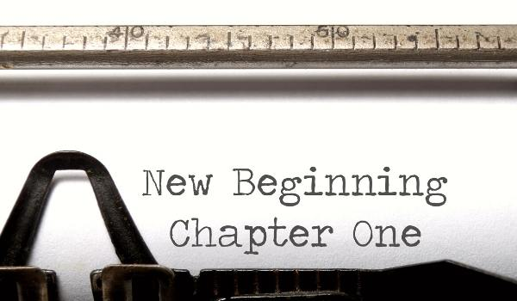
- For a righteous man may fall seven times and rise again, but the wicked shall fall by calamity. Proverbs 24:16 NKJV

Then He who sat on the throne said, “Behold, I make all things new.” And He said to me, “Write, for these words are true and faithful.” Revelation 21:5

